# Introduction to Computer Networks

* Modern world scenario is ever changing. Data Communication and network have changed the way business and other daily affair works. Now, they highly rely on computer networks and internetwork.
* A set of devices often mentioned as nodes connected by media link is called a Network.
* A node can be a device which is capable of sending or receiving data generated by other nodes on the network like a computer, printer etc. These links connecting the devices are called **Communication channels**.
* Computer network is a telecommunication channel using which we can share data with other computers or devices, connected to the same network. It is also called Data Network. The best example of computer network is Internet.
* Computer network does not mean a system with one Control Unit connected to multiple other systems as its slave. That is Distributed system, not Computer Network.
* A network must be able to meet certain criteria’s, these are mentioned below:

1. Performance
2. Reliability
3. Scalability

### Computer Networks: Performance

It can be measured in the following ways:

* **Transit time:**It is the time taken to travel a message from one device to another.
* **Response time:**It is defined as the time elapsed between enquiry and response.

Other ways to measure performance are:

1. Efficiency of software
2. Number of users
3. Capability of connected hardware

### Computer Networks: Reliability

It decides the frequency at which network failure take place. More the failures are, less is the network's reliability.

### Computer Networks: Security

It refers to the protection of data from any unauthorised user or access. While travelling through network, data passes many layers of network, and data can be traced if attempted. Hence security is also a very important characteristic for Networks.

## Properties of a Good Network

1. **Interpersonal Communication:** We can communicate with each other efficiently and easily. Example: emails, chat rooms, video conferencing etc, all of these are possible because of computer networks.
2. **Resources can be shared:**We can share physical resources by making them available on a network such as printers, scanners etc.
3. **Sharing files, data:**Authorised users are allowed to share the files on the network.

## Basic Communication Model

A Communication model is used to exchange data between two parties. For example: communication between a computer, server and telephone (through modem).

Basic Communication Model

### Communication Model: Source

Data to be transmitted is generated by this device, example: telephones, personal computers etc.

### Communication Model: Transmitter

The data generated by the source system is not directly transmitted in the form its generated. The transmitter transforms and encodes the data in such a form to produce electromagnetic waves or signals.

### Communication Model: Transmission System

A transmission system can be a single transmission line or a complex network connecting source and destination.

### Communication Model: Receiver

Receiver accepts the signal from the transmission system and converts it into a form which is easily managed by the destination device.

### Communication Model: Destination

Destination receives the incoming data from the receiver.

## Data Communication

The exchange of data between two devices through a transmission medium is called **Data Communication**. The data is exchanged in the form of **0's** and **1's**. The transmission medium used is wire cable. For data communication to occur, the communication device must be a part of a communication system. Data Communication has two types - **Local** and **Remote** which are discussed below:

### Data Communication: Local

Local communication takes place when the communicating devices are in the same geographical area, same building, or face-to-face etc.

### Data Communication: Remote

Remote communication takes place over a distance i.e. the devices are farther. The effectiveness of a data communication can be measured through the following features :

1. **Delivery**: Delivery should be done to the correct destination.
2. **Timeliness**: Delivery should be on time.
3. **Accuracy**: Data delivered should be accurate.

### Components of Data Communication

1. **Message:**It is the information to be delivered.
2. **Sender:**Sender is the person who is sending the message.
3. **Receiver:**Receiver is the person to whom the message is being sent to.
4. **Medium:**It is the medium through which the message is sent. For example: A Modem.
5. **Protocol:**These are some set of rules which govern data communication.

# Line Configuration in Computer Networks

A Network is nothing but a connection made through connection links between two or more devices. Devices can be a computer, printer or any other device that is capable to send and receive data. There are two ways to connect the devices :

1. Point-to-Point connection
2. Multipoint connection

## Point-To-Point Connection

It is a protocol which is used as a communication link between two devices. It is simple to establish. The most common example for Point-to-Point connection (PPP) is a computer connected by telephone line. We can connect the two devices by means of a pair of wires or using a microwave or satellite link.

**Example:** Point-to-Point connection between remote control and Television for changing the channels.

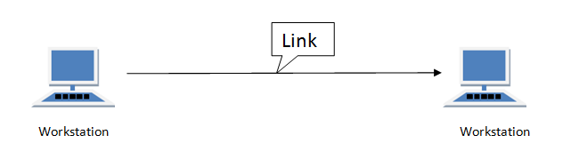

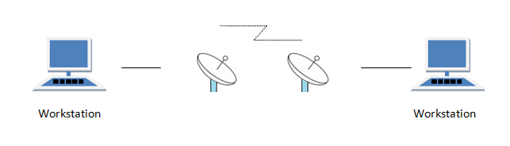

## MultiPoint Connection

It is also called Multidrop configuration. In this connection two or more devices share a single link.

There are two kinds of Multipoint Connections :

* If the links are used simultaneously between many devices, then it is spatially shared line configuration.
* If user takes turns while using the link, then it is time shared (temporal) line configuration.

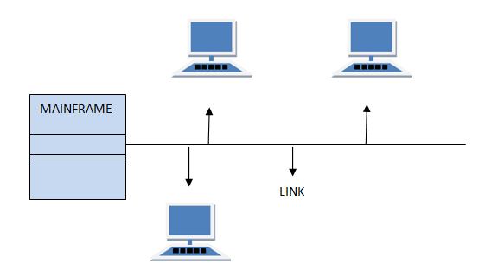

# Transmission Modes in Computer Networks

Transmission mode refers to the mechanism of transferring of data between two devices connected over a network. It is also called **Communication Mode**. These modes direct the direction of flow of information. There are three types of transmission modes. They are:

1. Simplex Mode
2. Half duplex Mode
3. Full duplex Mode

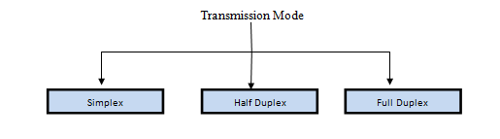

## SIMPLEX Mode

In this type of transmission mode, data can be sent only in one direction i.e. communication is unidirectional. We cannot send a message back to the sender. Unidirectional communication is done in Simplex Systems where we just need to send a command/signal, and do not expect any response back.

Examples of simplex Mode are loudspeakers, television broadcasting, television and remote, keyboard and monitor etc.

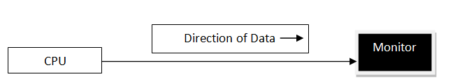

## HALF DUPLEX Mode

Half-duplex data transmission means that data can be transmitted in both directions on a signal carrier, but not at the same time.

**For example**, on a local area network using a technology that has half-duplex transmission, one workstation can send data on the line and then immediately receive data on the line from the same direction in which data was just transmitted. Hence half-duplex transmission implies a bidirectional line (one that can carry data in both directions) but data can be sent in only one direction at a time.

Example of half duplex is a walkie- talkie in which message is sent one at a time but messages are sent in both the directions.

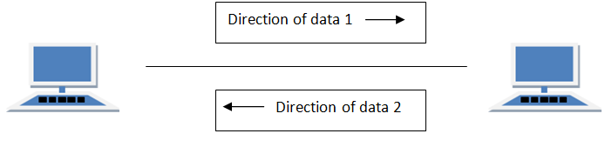

## FULL DUPLEX Mode

In full duplex system we can send data in both the directions as it is bidirectional at the same time in other words, data can be sent in both directions simultaneously.

Example of Full Duplex is a Telephone Network in which there is communication between two persons by a telephone line, using which both can talk and listen at the same time.

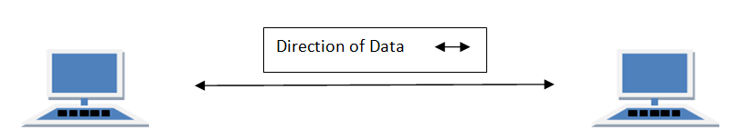

In full duplex system there can be two lines one for sending the data and the other for receiving data.

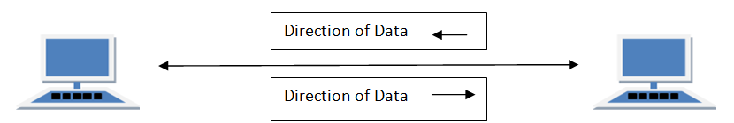

# Transmission Mediums in Computer Networks

Data is represented by computers and other telecommunication devices using signals. Signals are transmitted in the form of electromagnetic energy from one device to another. Electromagnetic signals travel through vacuum, air or other transmission mediums to move from one point to another(from sender to receiver).

Electromagnetic energy (includes electrical and magnetic fields) consists of power, voice, visible light, radio waves, ultraviolet light, gamma rays etc.

Transmission medium is the means through which we send our data from one place to another. The first layer (physical layer) of Communication Networks OSI Seven layer model is dedicated to the transmission media, we will study the OSI Model later.

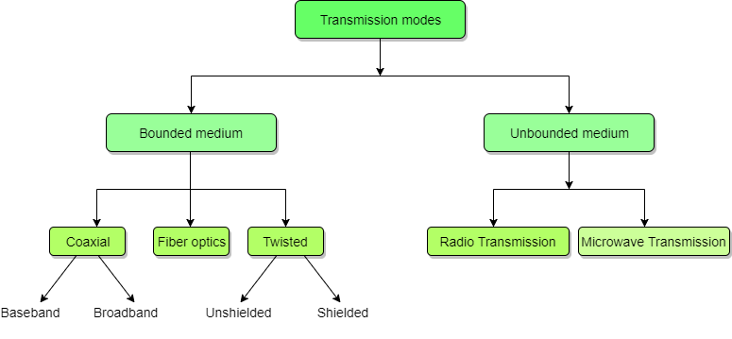

### Factors to be considered while selecting a Transmission Medium

1. Transmission Rate
2. Cost and Ease of Installation
3. Resistance to Environmental Conditions
4. Distances

**What is Network Topology?**

Network topology is the arrangement of the different networking elements like network links, computers, switches, nodes, Wi-Fi access points, laptops and other network devices in a computer network.

**There are two types of Network Topologies:**

* Physical Network topology and,
* Logical Network topology

### What is a Physical topology?

A Physical topology defines how all the network devices are connected physically in a computer network. It mostly defines the physical connections among the devices.

### What is a Logical topology?

A logical topology defines the logical connectivity of network devices on a computer network. So, it might happen that the devices connected in one type of physical topology might have different underlying logical topology.

If we elaborate more on the physical topology, it is essentially the placement of the various network components in a computer like the placement of the devices, the connection among the devices, installation of the cables etc. On the other hand, logical connection defines how data flows among the devices.

For example, let say there are five devices (A, B, C, D, and E) that are connected in a row. This configuration of network devices might look more like a Bus topology. But let’s say device A can directly transmit the data to the device E. That means it looks more like a Circle which a Ring topology logically but a bus topology physically.

***Short Bytes:*** Network topology is defined by two types — physical topology and the logical topology. While physical topology talks more about the geometry and physical placement of the devices on the same hand, logical topology is more about the way data communication or signalling happens among the devices.

## What is Point-to-point topology?

When we connect two network nodes end-to-end, it forms a point-to-point topology. For example, if I am the network administrator of the network of my institution and while troubleshooting I connect my laptop to a wireless router; this will form a case of Point-to-point topology. This also implies that if either node in the coupling gets down, my Point-to-point topology also gets down.

## What is Bus topology?

Bus topology is a network type in which every computer and network device is connected to single cable. When it has exactly two endpoints, then it is called **Linear Bus topology**.

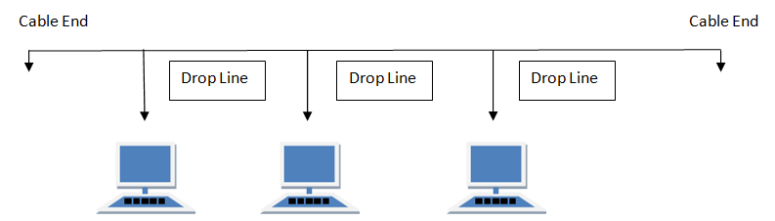

#### Features of Bus Topology

1. It transmits data only in one direction.
2. Every device is connected to a single cable

#### Advantages of Bus Topology

1. It is cost effective.
2. Cable required is least compared to other network topology.
3. Used in small networks.
4. It is easy to understand.
5. Easy to expand joining two cables together.

#### Disadvantages of Bus Topology

1. Cables fails then whole network fails.
2. If network traffic is heavy or nodes are more the performance of the network decreases.
3. Cable has a limited length.
4. It is slower than the ring topology.

## RING Topology:

It is called ring topology because it forms a ring as each computer is connected to another computer, with the last one connected to the first. Exactly two neighbours for each device.

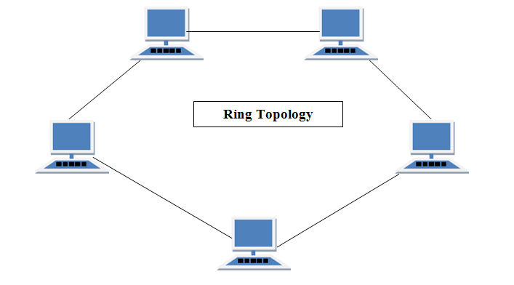

#### Features of Ring Topology

1. A number of repeaters are used for Ring topology with large number of nodes, because if someone wants to send some data to the last node in the ring topology with 100 nodes, then the data will have to pass through 99 nodes to reach the 100th node. Hence to prevent data loss repeaters are used in the network.
2. The transmission is unidirectional, but it can be made bidirectional by having 2 connections between each Network Node, it is called **Dual Ring Topology**.
3. In Dual Ring Topology, two ring networks are formed, and data flow is in opposite direction in them. Also, if one ring fails, the second ring can act as a backup, to keep the network up.
4. Data is transferred in a sequential manner that is bit by bit. Data transmitted, has to pass through each node of the network, till the destination node.

#### Advantages of Ring Topology

1. Transmitting network is not affected by high traffic or by adding more nodes, as only the nodes having tokens can transmit data.
2. Cheap to install and expand

#### Disadvantages of Ring Topology

1. Troubleshooting is difficult in ring topology.
2. Adding or deleting the computers disturbs the network activity.
3. Failure of one computer disturbs the whole network.

## STAR Topology

In this type of topology all the computers are connected to a single hub through a cable. This hub is the central node and all others nodes are connected to the central node.

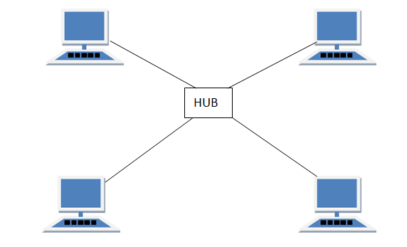

#### Features of Star Topology

1. Every node has its own dedicated connection to the hub.
2. Hub acts as a repeater for data flow.
3. Can be used with twisted pair, Optical Fibre or coaxial cable.

#### Advantages of Star Topology

1. Fast performance with few nodes and low network traffic.
2. Hub can be upgraded easily.
3. Easy to troubleshoot.
4. Easy to setup and modify.
5. Only that node is affected which has failed, rest of the nodes can work smoothly.

#### Disadvantages of Star Topology

1. Cost of installation is high.
2. Expensive to use.
3. If the hub fails then the whole network is stopped because all the nodes depend on the hub.
4. Performance is based on the hub that is it depends on its capacity

## MESH Topology

It is a point-to-point connection to other nodes or devices. All the network nodes are connected to each other. Mesh has n(n-1)/2 physical channels to link n devices.

There are two techniques to transmit data over the Mesh topology, they are :

1. Routing
2. Flooding

### MESH Topology: Routing

In routing, the nodes have a routing logic, as per the network requirements. Like routing logic to direct the data to reach the destination using the shortest distance. Or, routing logic which has information about the broken links, and it avoids those node etc. We can even have routing logic, to re-configure the failed nodes.

### MESH Topology: Flooding

In flooding, the same data is transmitted to all the network nodes, hence no routing logic is required. The network is robust, and the its very unlikely to lose the data. But it leads to unwanted load over the network.

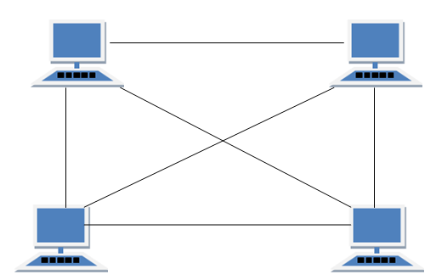

#### Types of Mesh Topology

1. **Partial Mesh Topology :**In this topology some of the systems are connected in the same fashion as mesh topology but some devices are only connected to two or three devices.
2. **Full Mesh Topology :**Each and every nodes or devices are connected to each other.

#### Features of Mesh Topology

1. Fully connected.
2. Robust.
3. Not flexible.

#### Advantages of Mesh Topology

1. Each connection can carry its own data load.
2. It is robust.
3. Fault is diagnosed easily.
4. Provides security and privacy.

#### Disadvantages of Mesh Topology

1. Installation and configuration is difficult.
2. Cabling cost is more.
3. Bulk wiring is required.

## TREE Topology

It has a root node and all other nodes are connected to it forming a hierarchy. It is also called hierarchical topology. It should at least have three levels to the hierarchy.

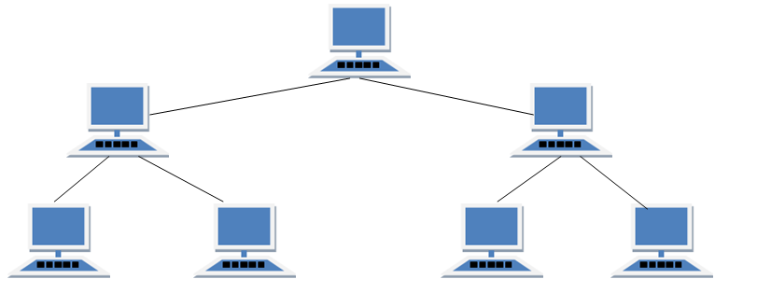

#### Features of Tree Topology

1. Ideal if workstations are located in groups.
2. Used in Wide Area Network.

#### Advantages of Tree Topology

1. Extension of bus and star topologies.
2. Expansion of nodes is possible and easy.
3. Easily managed and maintained.
4. Error detection is easily done.

#### Disadvantages of Tree Topology

1. Heavily cabled.
2. Costly.
3. If more nodes are added maintenance is difficult.
4. Central hub fails, network fails.

## HYBRID Topology

It is two different types of topologies which is a mixture of two or more topologies. For example if in an office in one department ring topology is used and in another star topology is used, connecting these topologies will result in Hybrid Topology (ring topology and star topology).

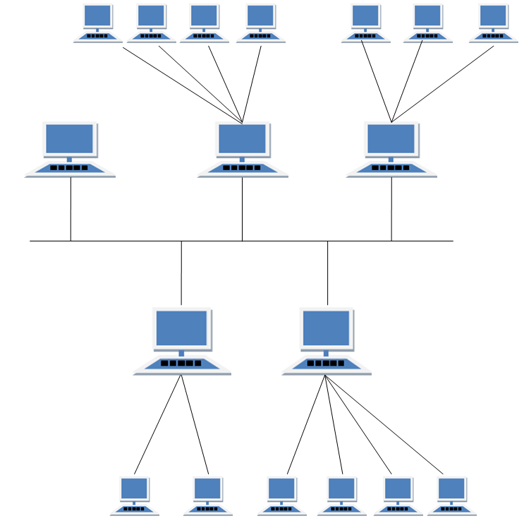

#### Features of Hybrid Topology

1. It is a combination of two or topologies
2. Inherits the advantages and disadvantages of the topologies included

#### Advantages of Hybrid Topology

1. Reliable as Error detecting and trouble shooting is easy.
2. Effective.
3. Scalable as size can be increased easily.
4. Flexible.

#### Disadvantages of Hybrid Topology

1. Complex in design.
2. Costly.

# Types of Communication Networks

Communication Networks can be of following 5 types:

1. Local Area Network (LAN)
2. Metropolitan Area Network (MAN)
3. Wide Area Network (WAN)
4. Wireless
5. Inter Network (Internet)

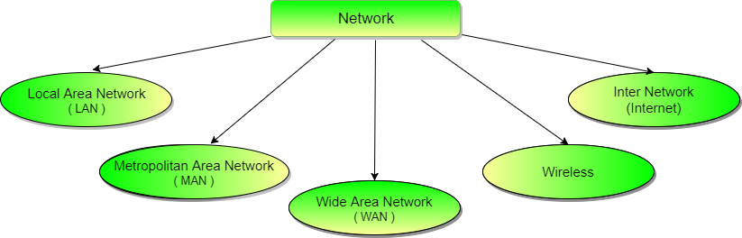

## Local Area Network (LAN)

It is also called LAN and designed for small physical areas such as an office, group of buildings or a factory. LANs are used widely as it is easy to design and to troubleshoot. Personal computers and workstations are connected to each other through LANs. We can use different types of topologies through LAN, these are Star, Ring, Bus, Tree etc.

LAN can be a simple network like connecting two computers, to share files and network among each other while it can also be as complex as interconnecting an entire building.

LAN networks are also widely used to share resources like printers, shared hard-drive etc.

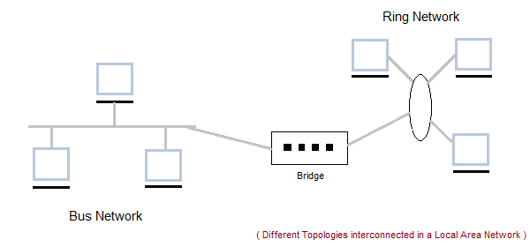

### Characteristics of LAN

* LAN's are private networks, not subject to tariffs or other regulatory controls.
* LAN's operate at relatively high speed when compared to the typical WAN.
* There are different types of Media Access Control methods in a LAN, the prominent ones are Ethernet, Token ring.
* It connects computers in a single building, block or campus, i.e. they work in a restricted geographical area.

### Applications of LAN

* One of the computer in a network can become a server serving all the remaining computers called clients. Software can be stored on the server and it can be used by the remaining clients.
* Connecting Locally all the workstations in a building to let them communicate with each other locally without any internet access.
* Sharing common resources like printers etc are some common applications of LAN.

### Advantages of LAN

* **Resource Sharing:** Computer resources like printers, modems, DVD-ROM drives and hard disks can be shared with the help of local area networks. This reduces cost and hardware purchases.
* **Software Applications Sharing:** It is cheaper to use same software over network instead of purchasing separate licensed software for each client a network.
* **Easy and Cheap Communication:** Data and messages can easily be transferred over networked computers.
* **Centralized Data:** The data of all network users can be saved on hard disk of the server computer. This will help users to use any workstation in a network to access their data. Because data is not stored on workstations locally.
* **Data Security:** Since, data is stored on server computer centrally, it will be easy to manage data at only one place and the data will be more secure too.
* **Internet Sharing:** Local Area Network provides the facility to share a single internet connection among all the LAN users. In Net Cafes, single internet connection sharing system keeps the internet expenses cheaper.

### Disadvantages of LAN

* **High Setup Cost:** Although the LAN will save cost over time due to shared computer resources, but the initial setup costs of installing Local Area Networks is high.
* **Privacy Violations:** The LAN administrator has the rights to check personal data files of each and every LAN user. Moreover he can check the internet history and computer use history of the LAN user.
* **Data Security Threat:** Unauthorised users can access important data of an organization if centralized data repository is not secured properly by the LAN administrator.
* **LAN Maintenance Job:** Local Area Network requires a LAN Administrator because, there are problems of software installations or hardware failures or cable disturbances in Local Area Network. A LAN Administrator is needed at this full time job.
* **Covers Limited Area:** Local Area Network covers a small area like one office, one building or a group of nearby buildings.

## Metropolitan Area Network (MAN)

It was developed in 1980s.It is basically a bigger version of LAN. It is also called MAN and uses the similar technology as LAN. It is designed to extend over the entire city. It can be means to connecting a number of LANs into a larger network or it can be a single cable. It is mainly hold and operated by single private company or a public company.

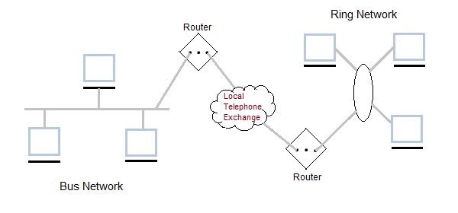

### Characteristics of MAN

* It generally covers towns and cities (50 km)
* Communication medium used for MAN are optical fibers, cables etc.
* Data rates adequate for distributed computing applications.

### Advantages of MAN

* Extremely efficient and provide fast communication via high-speed carriers, such as fibre optic cables.
* It provides a good back bone for large network and provides greater access to WANs.
* The dual bus used in MAN helps the transmission of data in both directions simultaneously.
* A MAN usually encompasses several blocks of a city or an entire city.

### Disadvantages of MAN

* More cable required for a MAN connection from one place to another.
* It is difficult to make the system secure from hackers and industrial espionage(spying) graphical regions.

## Wide Area Network (WAN)

It is also called WAN. WAN can be private or it can be public leased network. It is used for the network that covers large distance such as cover states of a country. It is not easy to design and maintain. Communication medium used by WAN are PSTN or Satellite links. WAN operates on low data rates.

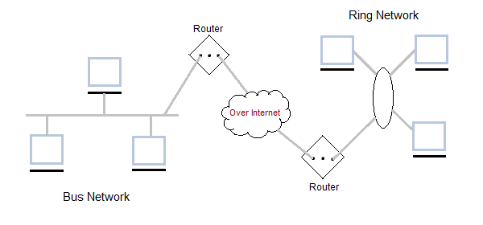

### Characteristics of WAN

* It generally covers large distances(states, countries, continents).
* Communication medium used are satellite, public telephone networks which are connected by routers.

### Advantages of WAN

* Covers a large geographical area so long distance business can connect on the one network.
* Shares software and resources with connecting workstations.
* Messages can be sent very quickly to anyone else on the network. These messages can have picture, sounds or data included with them(called attachments).
* Expensive things(such as printers or phone lines to the internet) can be shared by all the computers on the network without having to buy a different peripheral for each computer.
* Everyone on the network can use the same data. This avoids problems where some users may have older information than others.

### Disadvantages of WAN

* Need a good firewall to restrict outsiders from entering and disrupting the network.
* Setting up a network can be an expensive, slow and complicated. The bigger the network the more expensive it is.
* Once set up, maintaining a network is a full-time job which requires network supervisors and technicians to be employed.
* Security is a real issue when many different people have the ability to use information from other computers. Protection against hackers and viruses adds more complexity and expense.

## Wireless Network

Digital wireless communication is not a new idea. Earlier, **Morse code** was used to implement wireless networks. Modern digital wireless systems have better performance, but the basic idea is the same.

Wireless Networks can be divided into three main categories:

1. **System interconnection**
2. **Wireless LANs**
3. **Wireless WANs**

### System Interconnection

System interconnection is all about interconnecting the components of a computer using **short-range radio**. Some companies got together to design a short-range wireless network called **Bluetooth** to connect various components such as monitor, keyboard, mouse and printer, to the main unit, without wires. Bluetooth also allows digital cameras, headsets, scanners and other devices to connect to a computer by merely being brought within range.

In simplest form, system interconnection networks use the master-slave concept. The system unit is normally the **master**, talking to the mouse, keyboard, etc. as **slaves**.

### Wireless LANs

These are the systems in which every computer has a **radio modem** and **antenna** with which it can communicate with other systems. Wireless LANs are becoming increasingly common in small offices and homes, where installing **Ethernet** is considered too much trouble. There is a standard for wireless LANs called **IEEE 802.11**, which most systems implement and which is becoming very widespread.

### Wireless WANs

The radio network used for cellular telephones is an example of a low-bandwidth wireless WAN. This system has already gone through three generations.

* The first generation was analog and for voice only.
* The second generation was digital and for voice only.
* The third generation is digital and is for both voice and data.

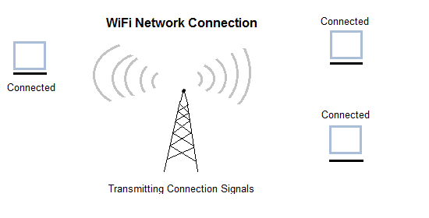

## Inter Network

Inter Network or Internet is a combination of two or more networks. Inter network can be formed by joining two or more individual networks by means of various devices such as routers, gateways and bridges.

